KE53 -

Functionality

A profit center is a management-oriented organizational unit used for internal controlling purposes. Dividing your company up into profit centers allows you to analyze areas of responsibility and to delegate responsibility to decentralized units, thus treating them as "companies within the company".
Create, Maintain and Display Profit Center Master data.

Scenario
Display Profit Center 1302 (MTBE - Oxygenates), and examine the relevant data (i.e. Long text of the Profit Center name, Responsible Person, Profit Center Group, Company codes allowed to post to it) and change documents.

Menu Path | SAP menu → Accounting → Controlling → Profit Center Accounting → Master Data → Profit Center → Individual Processing → KE53 - Display
Transaction Code | KE53

1. Double Click on KE53 - Display.

Display Profit Center

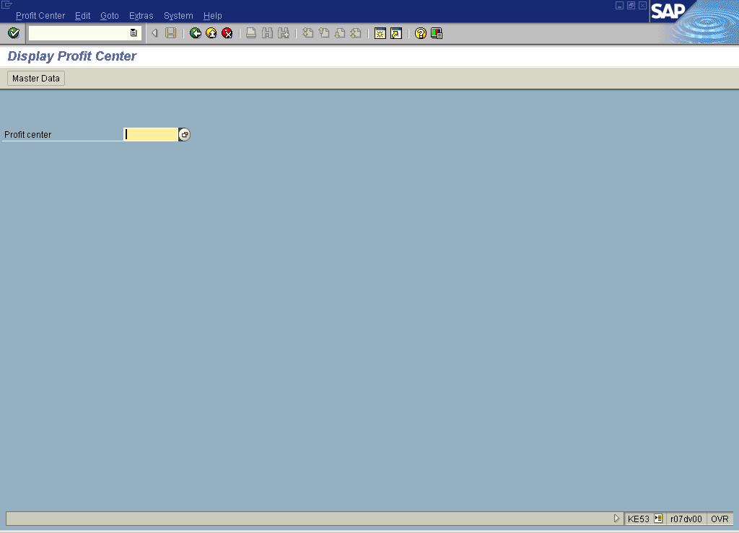

2. Update the following fields:

Field Name | Field Description | Values
Profit center | Code identifying an organizational object for which an independent operating profit is calculated | Example: 1302

Or

3. Click Matchcode button.

Restrict value range (1)

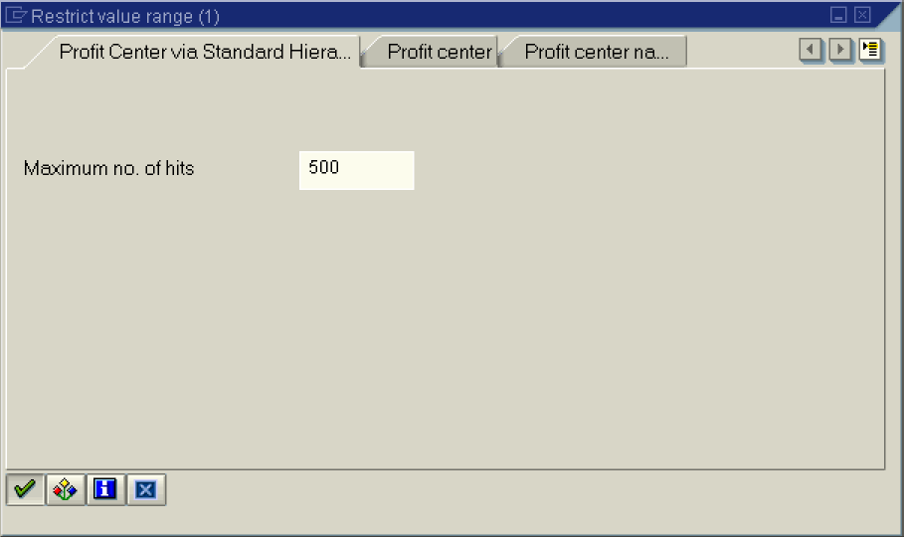

4. Click the Enter button.

Search Help for Standard Hierarchy

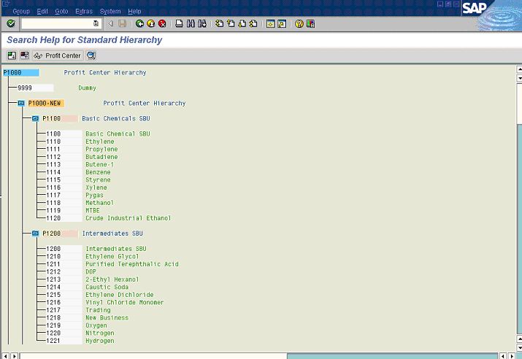

5. Double click on Profit Center.

OR

6. Click Master Data Button .

Display Profit Center

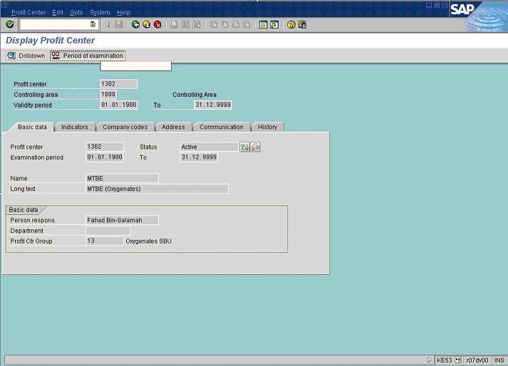

7. Click Period of examination Button .

Set analysis period

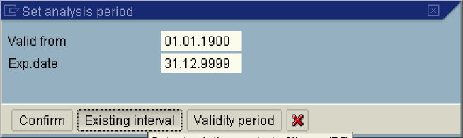

8. Click Existing interval Button .

Select existing period of time

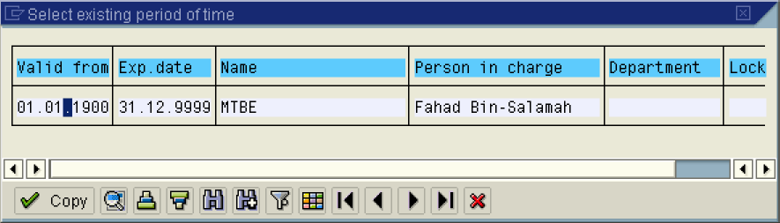

9. Click 01.01.1900 .

Display Profit Center

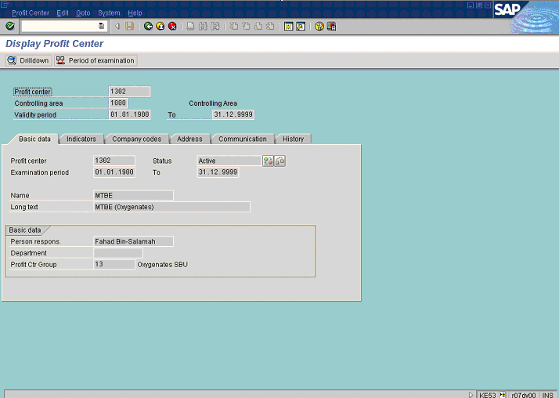

10. Click <tab button> Indicators .

Display Profit Center

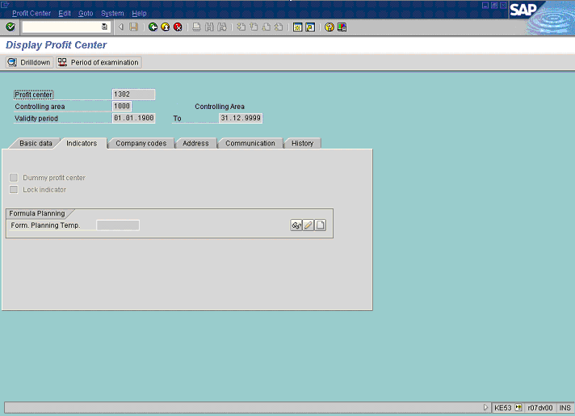

11. Click <tab button> Company codes .

Display Profit Center

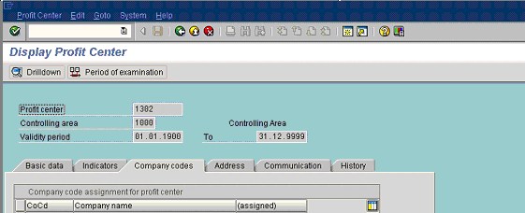

12. Click <tab button> Address .

Display Profit Center

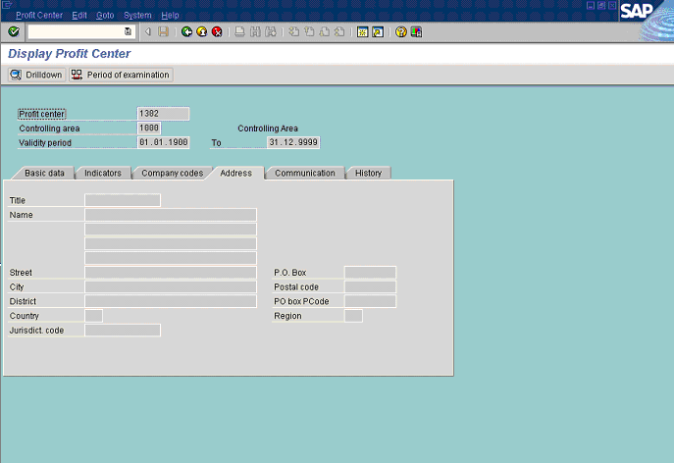

13. Click <tab button> Communication .

Display Profit Center

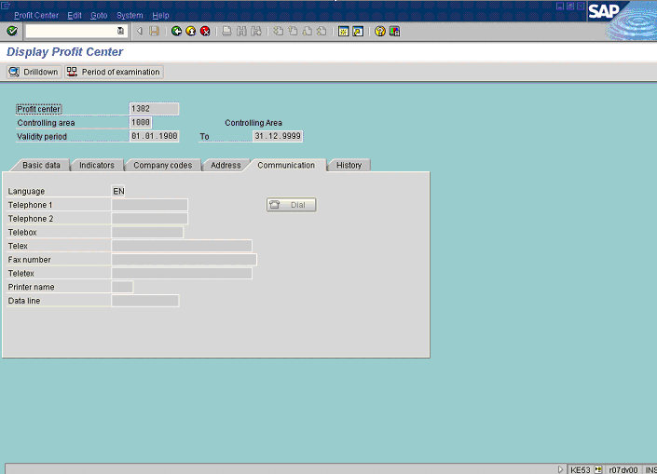

14. Click <tab button> History .

Display Profit Center

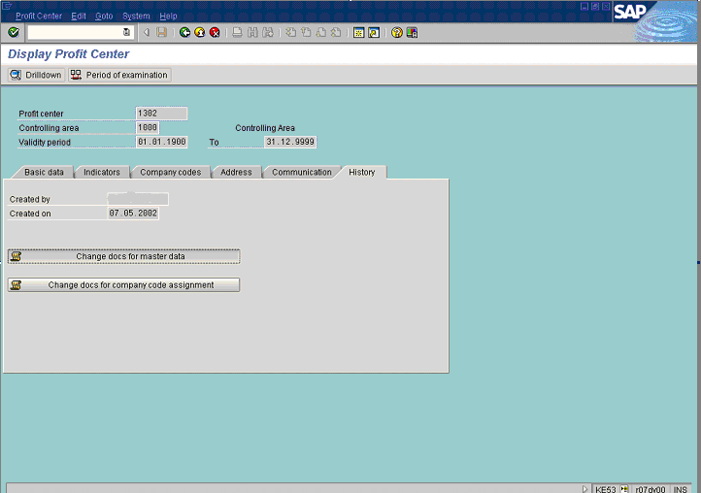

15. Click Change docs for master data Button .

General Master Data Record Changes

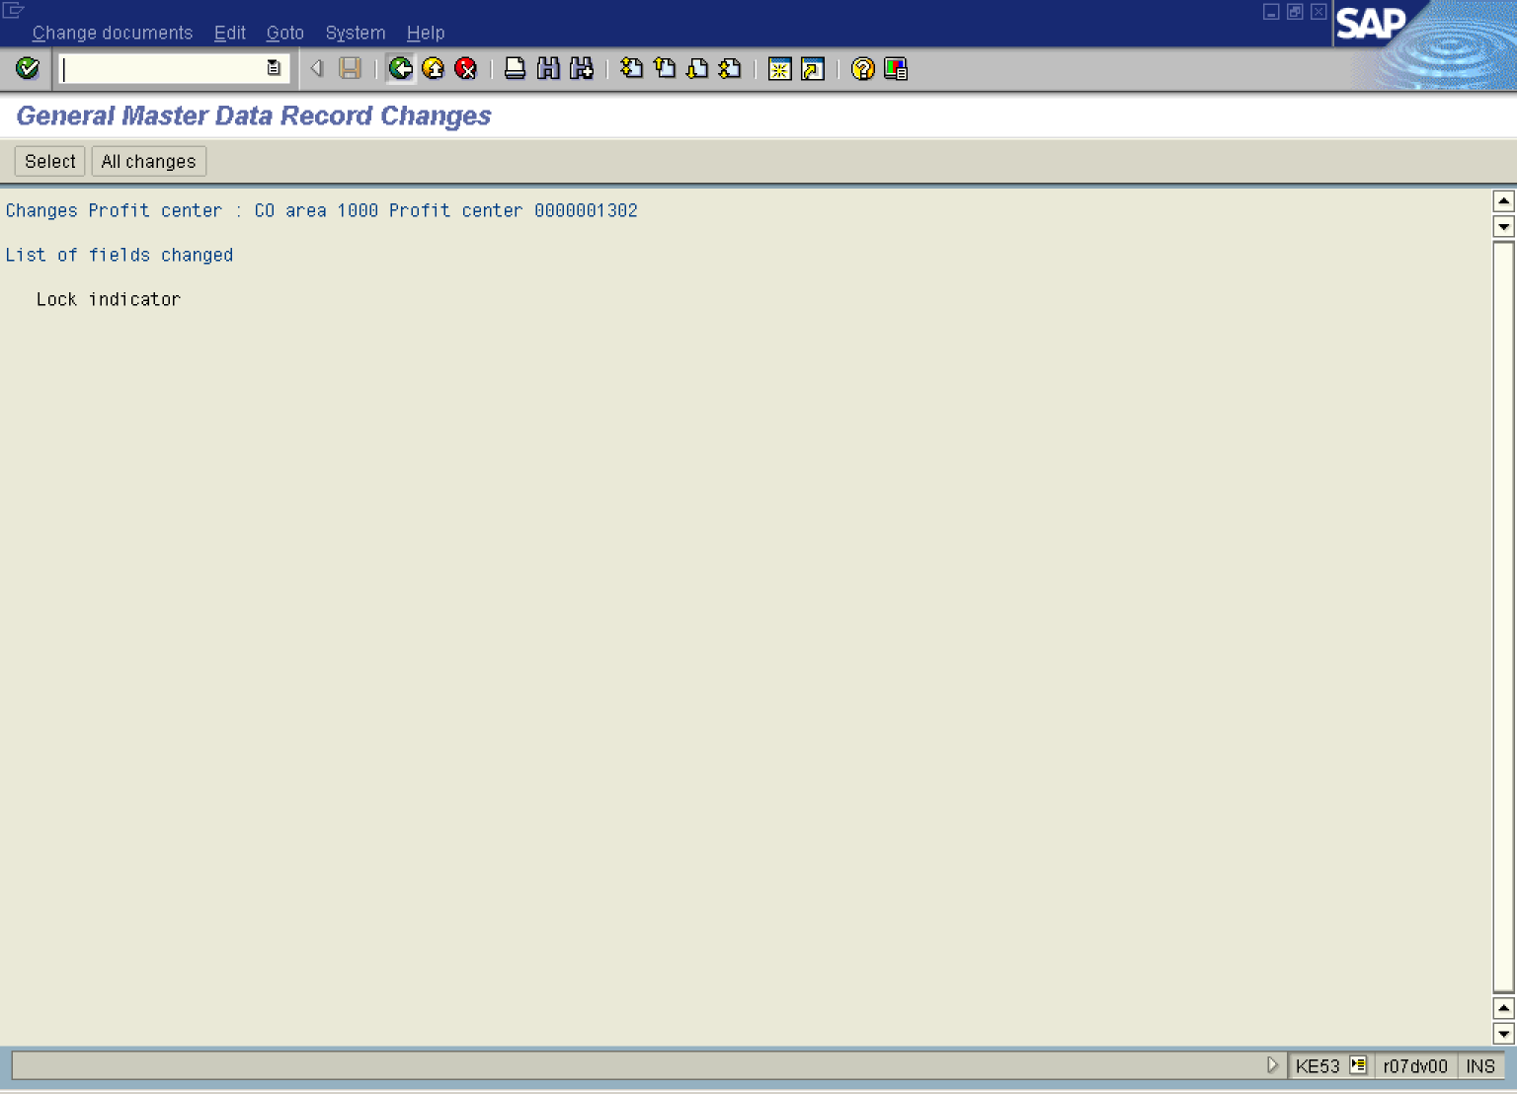

16. Click Back .

Display Profit Center

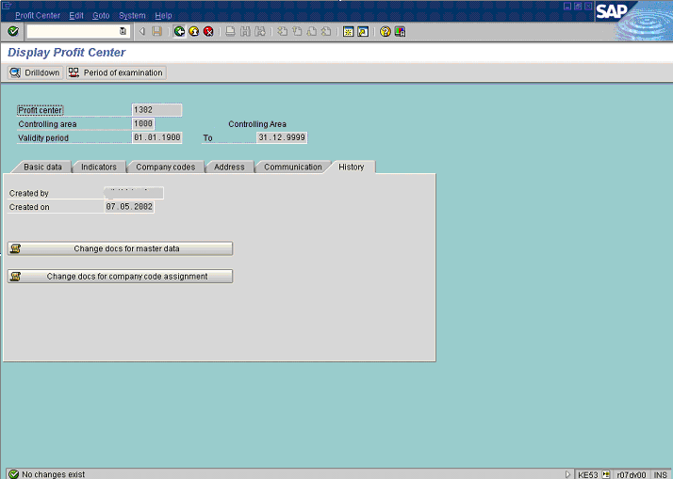

17. Click Change docs for company code assignment Button .

18. The message bar displays “No changes exist”

19. Click Back .

